Subject: Optical Communication and Networks

Class/Sem: BE EXTC/VIII

Module 6

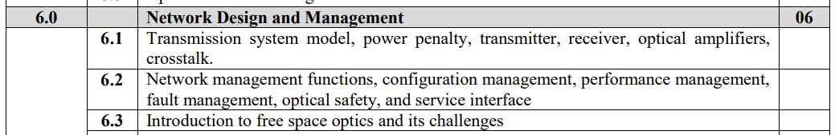

**Transmission System Model**

The following figure shows a block diagram of the various components of a unidirectional WDM link.

* The transmitter consists of a set of DFB lasers, with or without external modulators, one for each wavelength. The signals at the different wavelengths are combined into a single fiber by means of an optical multiplexer.
* An optical power amplifier may be used to increase the transmission power. After some distance along the fiber, the signal is amplified by an optical in-line amplifier. Depending on the distance, bit rate, and type of fiber used, the signal may also be passed through a dispersion-compensating module, usually at each amplifier stage.
* At the receiving end, the signal may be amplified by an optical preamplifier before it is passed through a demultiplexer. Each wavelength is then received by a separate photodetector.
* The physical layer of the system must ensure that bits are transmitted from the source to their destination reliably. The measures of quality are the bit error rate (BER) and the additional power budget margin provided in the system. Usually the required bit error rates are of the order of 10 -9 to 10-15, typically 10-12. The BER depends on the amount of noise as well as other impairments that are present in the system.
* Assume that non-return-to-zero (NRZ) modulation is used. In some specific cases, such as chromatic dispersion, both NRZ and return-to-zero (RZ) modulation will be considered. The physical layer is also responsible for the link initialization and link takedown procedures, which are necessary to prevent exposure to potentially harmful laser radiation.



**Power Penalty:**

* The physical layer design must take into account the effect of a number of system impairments. Usually, impairment results in a power penalty to the system. In the presence of impairment, a higher signal power will be required at the receiver in order to maintain a desired bit error rate. One way to define the power penalty is as the increase in signal power required (in dB) to maintain the same bit error rate in the presence of impairments. Another way to define the power penalty is as the reduction in signal-to-noise ratio as quantified by the value of γ (the argument to the Q(.) due to a specific impairment.

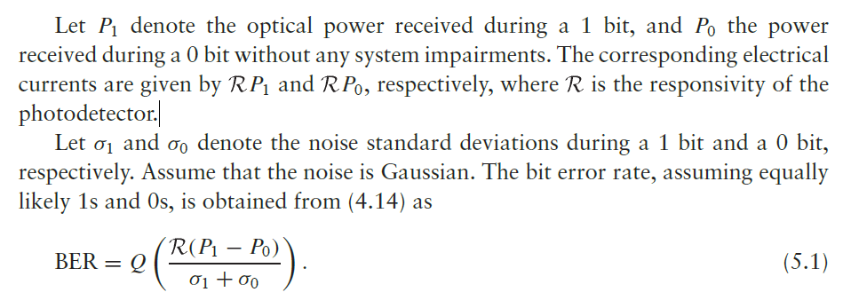

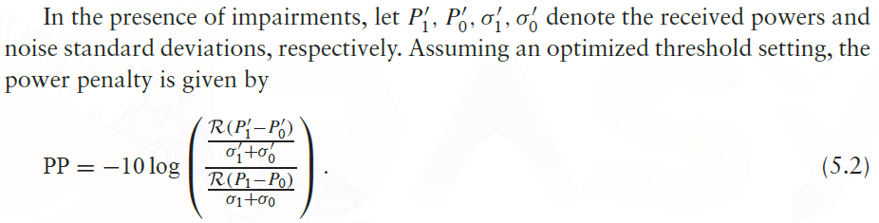

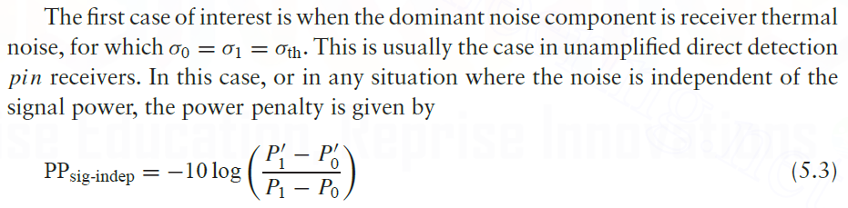

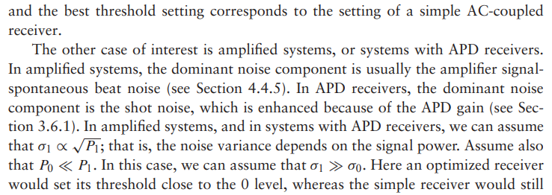

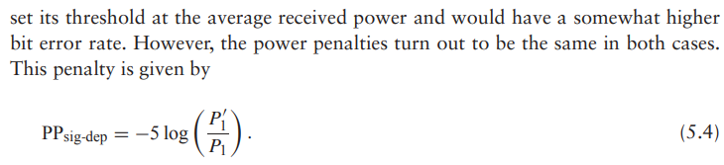

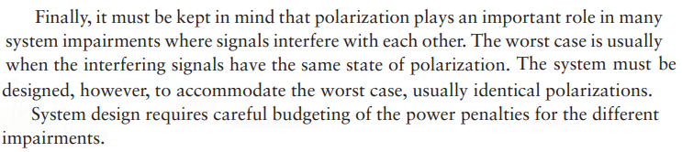

**Crosstalk:**

Crosstalk is the general term given to the effect of other signals on the desired signal. Almost every component in a WDM system introduces crosstalk of some form or another. The components include filters, wavelength multiplexers/demultiplexers, switches, semiconductor optical amplifiers, and the fiber itself (by way of nonlinearities). Two forms of crosstalk arise in WDM systems: interchannel crosstalk and intrachannel crosstalk.

* The first case is when the crosstalk signal is at a wavelength sufficiently different from the desired signal’s wavelength that the difference is larger than the receiver’s electrical bandwidth. This form of crosstalk is called interchannel crosstalk. Interchannel crosstalk can also occur through more indirect interactions, for example, if one channel affects the gain seen by another channel, as with nonlinearities.

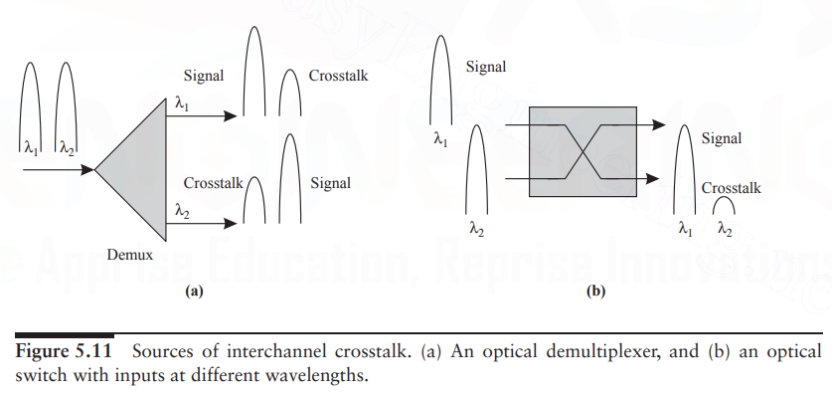

* The second case is when the crosstalk signal is at the same wavelength as that of the desired signal or sufficiently close to it that the difference in wavelengths is within the receiver’s electrical bandwidth. This form of crosstalk is called intrachannel crosstalk or, sometimes, coherent crosstalk.

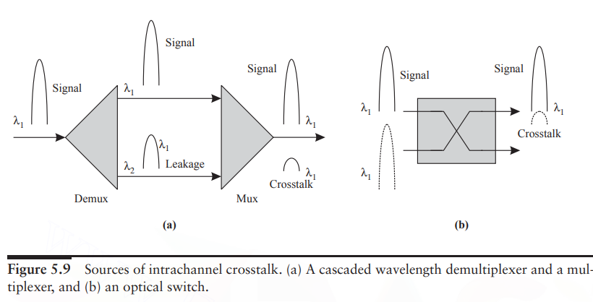

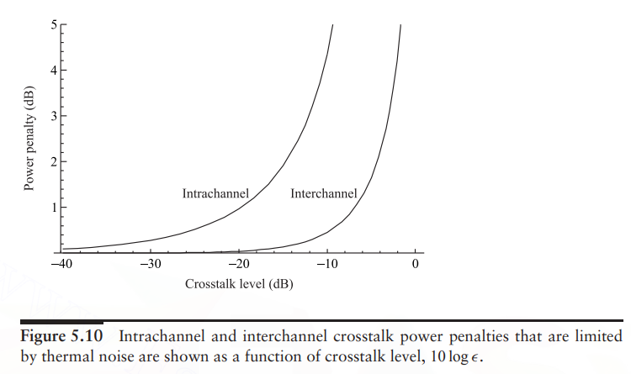

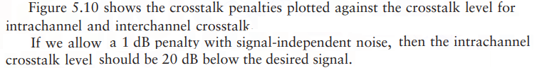

**Transmitter:**

* The key system design parameters related to the transmitter are its output power, rise-/fall-time, extinction ratio, modulation type, side-mode suppression ratio, relative intensity noise (RIN), and wavelength stability and accuracy.
* The output power depends on the type of transmitter.
* DFB lasers put out about 1 mW (0 dBm) to 10 mW (10 dBm) of power.
* An optical power amplifier can be used to boost the power, typically to as much as 50 mW (17 dBm).
* The upper limits on power are dictated by nonlinearities and safety considerations.
* The extinction ratio is defined as the ratio of the power transmitted when sending a 1 bit, P1, to the power transmitted when sending a 0 bit, P0.
* Assuming that we are limited to an average transmitted power P, we would like to have P1 = 2P and P0 = 0.
* This would correspond to an extinction ratio r =∞.
* Practical transmitters, however, have extinction ratios between 10 and 20.
* With an extinction ratio r, we have

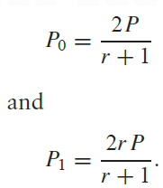

* Reducing the extinction ratio reduces the difference between the 1 and 0 levels at the receiver and thus produces a penalty.
* The power penalty due to a nonideal extinction ratio in systems limited by signal-independent noise is obtained from (5.3) as

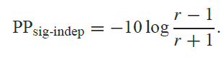

**Receiver:**

* The key system parameters associated with a receiver are its *sensitivity* and *overload parameter*.
* The sensitivity is the average optical power required to achieve a certain bit error rate at a particular bit rate.
* It is usually measured at a bit error rate of
* 10−12 using a pseudorandom 223 − 1 bit sequence.
* The overload parameter is the maximum input power that the receiver can accept.
* Typical sensitivities of different types of receivers for a set of bit rates are shown in Table 5.2.
* APD receivers have higher sensitivities than pinFET receivers and are typically used in high-bit-rate systems operating at

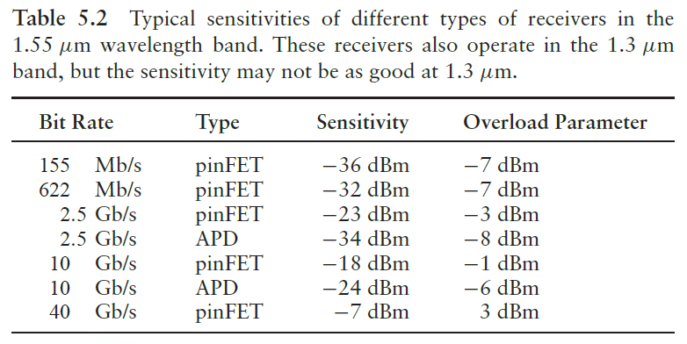

* Pin FET receiver with an optical preamplifier has a sensitivity that is comparable to an APD receiver.
* The overload parameter defines the dynamic range of the receiver and can be as high as 0 dBm for 2.5 Gb/s receivers, regardless of the specific receiver type.

**Optical Amplifiers**

* Optical amplifiers-to compensate for system losses.
* Erbium-doped fiber amplifier (EDFA) operating in the C-band.
* L-band EDFAs and Raman amplifiers are also used.
* EDFAs are used in almost all amplified WDM systems, whereas Raman amplifiers are used in addition to EDFAs in many ultralong- haul systems.
* The newer L-band EDFAs are being installed today to increase the available bandwidth, and available bandwidth, and hence the number of wavelengths, in a single fiber.
* Amplifiers are used in three different configurations, as shown in Figure 5.2.

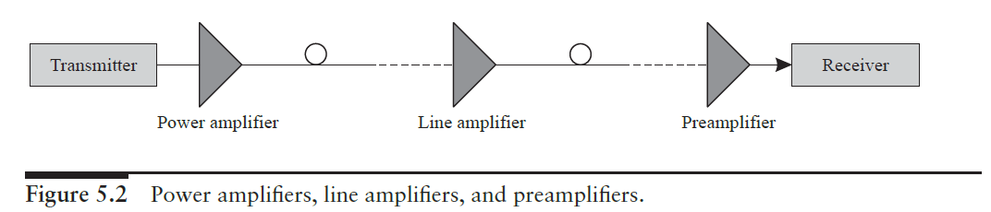

* An optical *preamplifier* is used just in front of a receiver to improve its sensitivity.
* A *power amplifier* is used after a transmitter to increase the output power.
* A *line amplifier* is typically used in the middle of the link to compensate for link losses.
* There are several major imperfections that system designers need to worry about when using amplifiers in a system.
* First, an amplifier introduces noise, in addition to providing gain.
* Second, the gain of the amplifier depends on the total input power.

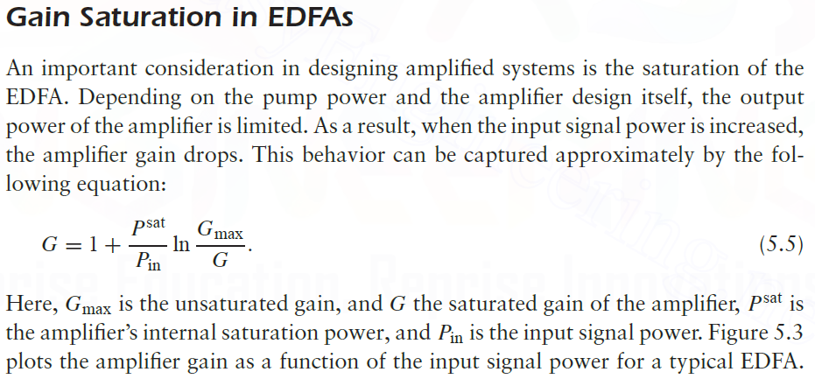

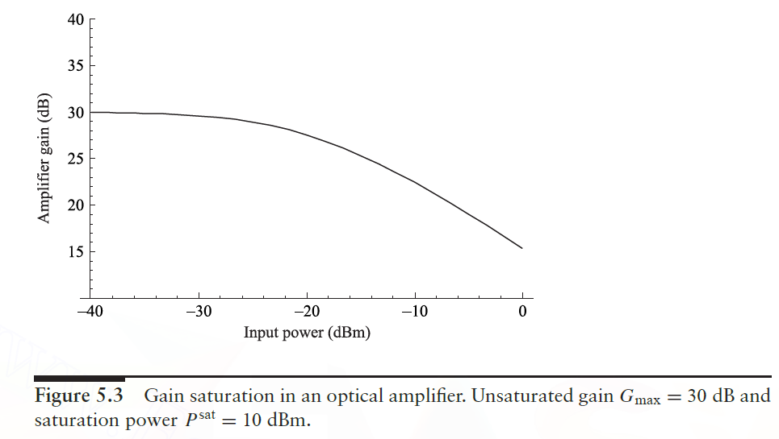

**Crosstalk in WDM:**

It is the effect of other signals on the desired signal. Almost every component in a WDM system introduces crosstalk. E.g. Filters, wavelength multiplexers/demultiplexers, switches, semiconductor optical amplifiers, and the fiber itself due to nonlinearities.

Two forms of crosstalk arise in WDM systems:

* Interchannel crosstalk and
* Intrachannel crosstalk.

**Intrachannel crosstalk**

When the crosstalk signal is at the same wavelength as that of the desired signal. Difference in wavelengths is within the receiver’s electrical bandwidth. Sometimes, called as coherent crosstalk. Intrachannel crosstalk effects can be much more severe than interchannel crosstalk.

In both cases, crosstalk results in a power penalty. Intrachannel crosstalk arises in transmission links due to reflections. Arises from cascading a wavelength demultiplexer (demux) with a wavelength multiplexer (mux), as shown in Figure 5.9(a).

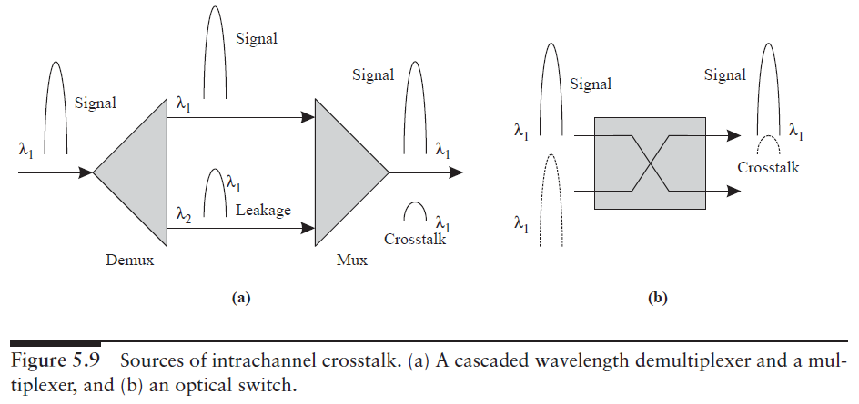

The demux ideally separates the incoming wavelengths to different output fibers. A portion of the signal at one wavelength, say, λi , leaks into the adjacent channel λi+1 because of nonideal suppression within the demux.

When the wavelengths are combined again into a single fiber by the mux, a small portion of the λi that leaked into the λi+1 channel will also leak back into the common fiber at the output.

Although both signals contain the same data, they are not in phase with each other, due to different delays they encounter. This causes intrachannel crosstalk.

Another source of this type of crosstalk arises from optical switches, as shown in Figure 5.9(b), due to the nonideal isolation of one switch port from the other. In this case, the signals contain different data. The crosstalk penalty is highest when the state of polarization (SOP) of the crosstalk signal is the same as the SOP of the desired signal.

When the crosstalk signal is exactly out of phase with the desired signal. The phase relationship between the two signals can vary over time due to several factors, including temperature variations. Design the system to work even if the two SOPs happen to match and the signals are exactly out of phase, which is the worst-case scenario.

**Interchannel crosstalk**

When the crosstalk signal is at a wavelength sufficiently different from the desired signal’s wavelength. The difference is larger than the receiver’s electrical bandwidth. For example, gain of one channel is affected by other channels.

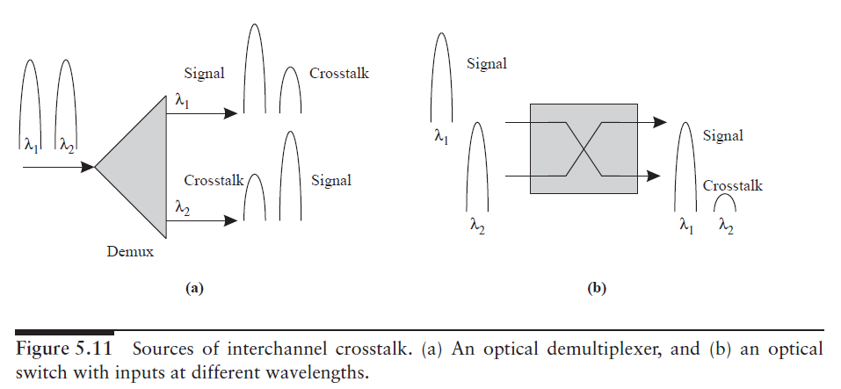

**Crosstalk in Networks:**

When signal propagates through many nodes and accumulates crosstalk from different elements at each node. Examples of such elements are muxes/demuxes and switches. Crosstalk suppression becomes particularly important in networks.

**Bidirectional Systems**

In a bidirectional transmission system, data is transmitted in both directions over a single fiber, as shown in Figure 5.13. Additional crosstalk mechanisms arise in these systems.

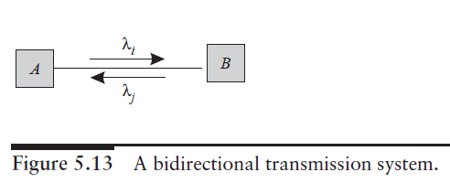

Bidirectional systems typically use different wavelengths in different directions. The two directions can be separated at the ends either by using an optical circulator or a WDM mux/demux, as in Figure 5.14.

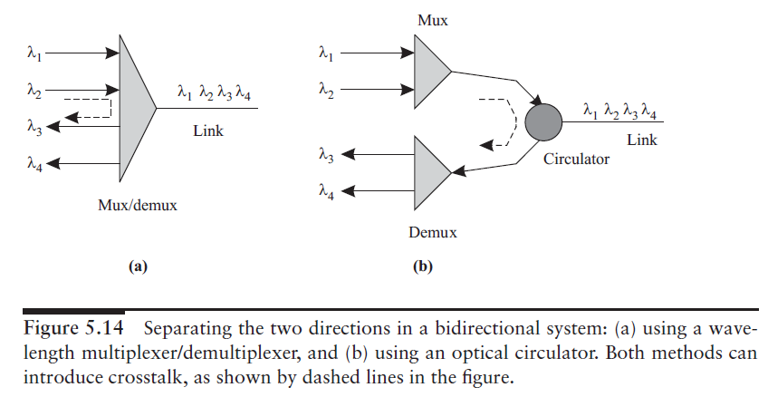

Although the laws of physics do not prevent the same wavelength from being used for both directions of transmissions, this is not a good idea in practice because of reflections. A back-reflection from a point close to the transmitter at one end, say, end A, will send a lot of power back into A’s receiver, creating a large amount of crosstalk.

In fact, the reflected power into A may be larger than the signal power received from the other end B. Reflections within the end equipment can be carefully controlled, but it is more difficult to restrict reflections from the fiber link itself.

For this reason, bidirectional systems typically use different wavelengths in different directions. The two directions can be separated at the ends either by using an optical circulator or a WDM mux/demux, as in Figure 5.14. (If the same

wavelength must be used in both directions, one alternative that is sometimes used in short-distance access networks is to use time division multiplexing where only one end transmits at a time.)

**Crosstalk Reduction**

Crosstalk should be suppressed at the device level. Various approaches are

* Spatial dilation
* Wavelength dilation
* Addition of filters for each wavelength

The first approach is to use spatial dilation, which is illustrated in Figure 5.15.

Figure 5.15(a) shows a 2×2 optical switch with crosstalk.Some unused ports are added. Demerit: No. of switched get doubled

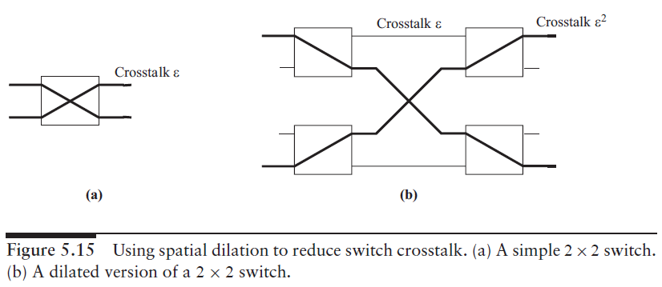

To improve the crosstalk suppression, we can dilate the switch, as shown in Figure 5.15(b), by adding some unused ports to it. Now the crosstalk is reduced to 2. The drawbacks of dilation are that it cannot be achieved without a significant increase in the number of switches. Demerit: Usually, the number of switches is doubled.